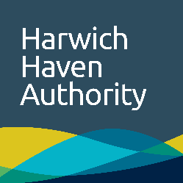 | Launch indemnity

Company details
Company name |  | Contact name
Address
Telephone
Fax
Passengers

Indemnity
Name of company
Shall ensure that all persons (including, but not necessarily limited to, those named above) (“Passengers”) using Harwich Haven Authority marine craft at its request shall be made aware of and sign the current Harwich Haven Authority disclaimer in advance of any use of the Authority’s marine craft.
Name of company
Shall indemnify, defend and hold harmless Harwich Haven Authority, its Directors, Officers, Agents and employees from and against any and all loss and liability for claims, demands, arbitral awards, suits or causes of action at law for injuries (including death) of every kind and nature to such passengers or damage to property accompanying such passengers, or both, occurring during carriage on such marine craft and the process of boarding, landing embarking or disembarking such passengers and property accompanying such passengers, or both, from any vessel, quay or pontoon using a Harwich Haven Authority marine craft, or failure by such Passengers to sign the disclaimer, save where such loss or damage is caused by the negligence of HHA or its employees.
Name of company
Shall at its own expense pay all judgements, settlements, damages and expenses including without limitation legal fees and expenses of whatsoever kind or nature arising out of or resulting from any such claims, demands, arbitral awards, suits or causes of action.

Authorisation
I confirm that all passengers using Harwich Haven Authority marine craft at its request shall hold an appropriate form of identification, be equipped with the appropriate and correct personal protective clothing and equipment and comply with ant directions as required by Harwich Haven Authority has the right to refuse passage.
Signature |  | Date
Name (PRINT)
Title
Additional Emergency and Health and Safety information is provided at www.hha.co.uk or through your Authority contact. Please return to Harwich Haven Authority – Fax Number +44 (0)1255 507177

