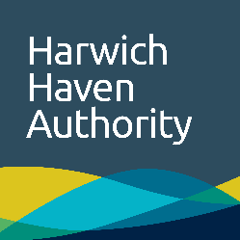 | Shipping and landing request

Request details
Date |  | Vessel
Location

Personnel to transport
No of persons |  | No of lifejackets required
Single journey |  | Return journey

Personnel Details
 | Person 1 |  | Person 2
Name
Position
Telephone

Invoice Details
Company Name |  | Contact Name
Address
Telephone |  | Fax

Indemnity
Name of Agent
Shall indemnify, defend and hold harmless Harwich Haven Authority, its Directors, Officers, Agents and employees from and against any and all loss and liability for claims, and nature of person(s) or property damage, or both, occurring during the process of boarding or landing such person(s) or property, or both, from a vessel using a Harwich Haven Authority launch.
Name of Agent
Shall at its own expense pay all judgements, settlement, damages and expenses including without limitation reasonable attorney’s fees and expenses of whatsoever kind or nature arising out of or resulting from any such claims, demands, arbitral awards, suits or causes of action.

Declaration
I confirm the person(s) named above shall hold an appropriate form of identification and that the vessel to which they are being transported is aware of their identity and is expecting their arrival. Harwich Haven Authority has the right to refuse passage if the amount or weight of baggage cannot be safely carried on board by the person(s) being transported without assistance.
Signature |  | Date
Name (PRINT)
Please return to Harwich Haven Authority Operations Centre – Fax Number: +44 (0)1255 507177

