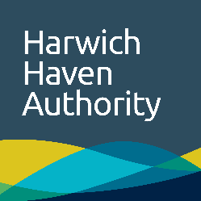 | PEC towage familiarisation

Introduction
Name
Please allow the PEC candidate to observe a towage operation with the explanation of towage safety and procedures (if a towage operation is not possible a full familiarisation and procedures explanation should be carried out). This form should then be completed and returned in confidence to the Harbour Master as soon as possible.

Towage operation
Vessel |  | LOA
Act from / to |  | Date |  | Time
Act to / from |  | Tide |  | Weather

Assessment
 | Good | Satisfactory | Insufficient | Poor
General towage communications procedures
Knowledge of tug specifications (bollard pull etc) pull / gear
Knowledge of towage procedures
Knowledge of towage safety
Knowledge of tug manoeuvring

General remarks

Tug skipper declaration
Signature |  | Date
Name (PRINT)

